# Set Up and Configuration

### Connecting to a hotspot

To connect Buddy and other devices to the same network using a Nokia 2.3 phone, follow these steps:

* Insert a SIM card into the Nokia 2.3 phone.
* Open the application menu by swiping up and tap on the **Settings** icon.
* Navigate to **Mobile** > **Mobile Data On** > **Personal Hotspot**, then toggle **Allow Others to Join** to the **On** position.

Once the hotspot is enabled, data usage for the SIM card will be billed on a per-usage basis. This setup allows any compatible equipment, including Buddy and your mobile device, to connect to the mobile hotspot for seamless operation.

### Connecting to a LAN Wi-Fi

Follow these simple steps to connect Buddy to the LAN Wi-Fi network:

* Open Settings on your mobile phone.
* Turn on your Wi-Fi connection.
* Select the local LAN Wi-Fi network named "Campus Clubhouse" and connect.
* Open the Yanshee App on your phone.
* Tap the robot search icon in the top-right corner of the app's main screen to scan for robots on the LAN Wi-Fi.
* When Robot Yanshee is detected, select Buddy and tap Next.
* Buddy will confirm by saying, "Yanshee is ready for action.

Your Buddy is now connected and ready to go!

# Programming Buddy

**Method 1:**

Download Yanshee APP, make sure your phone's Wi-Fi, Bluetooth and GPS are turned on, then click the icon on the top right corner of the APP main interface for robot search and network connection, you can confirm the device according to the last four digits of the Wi-Fi MAC address on the label on the back of the robot.

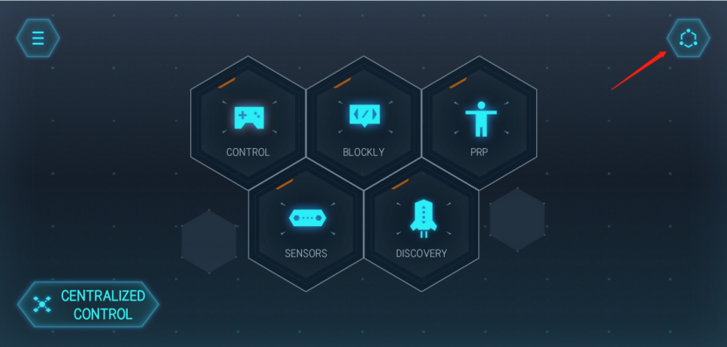

**Method 2:**

(1) Connect the robot to the display through the HDMI output port above Yanshee's chest.

(2) Connect keyboard and mouse through the USB port on the side of Yanshee (Wireless keyboard and mouse are recommended).

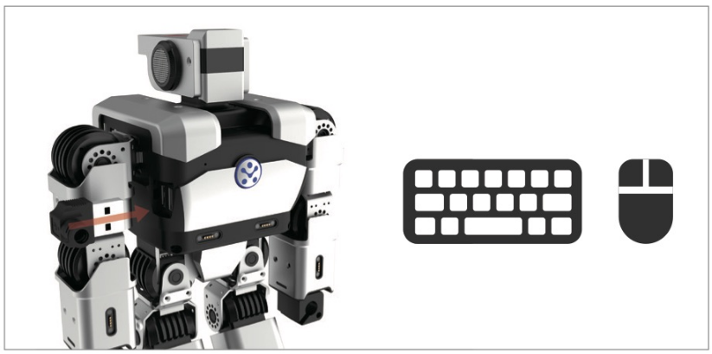

(3) Access the Yanshee operating system after powering on, and click the network icon in the upper right corner to realize the network connection.

